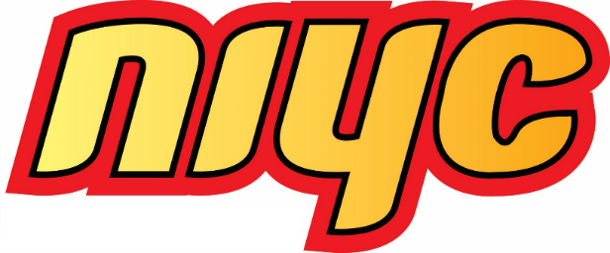
NIYC President
Nomination Form

Nominator Checklist
- A supporting letter that outlines the candidate’s experience in leadership roles, knowledge of issues important to Inuit youth, and a description of why the nominee is an ideal candidate for NIYC President
- A completed Nomination Form, with nominator and candidate signatures;
- Digital photo of passport quality (simple background, no sunglasses or hat), and;
- Current Level 1 Criminal Reference Check (one for each province/territory in which the individual has resided over the past five years for the candidate.

Nominator Instructions
Inuit between 18 and 35 years of age who are enrolled under an Inuit Nunangat Land Claims Agreement may nominate another Inuk enrolled under an Inuit Nunangat Land Claims Agreement and between 18 and 30 years of age as of the election date by submitting a nomination form and the following documents to the NIYC Elections Officer no later than 5:00 pm ET on May 23, 2025:

Forms, Rules, and Contact Information
The Candidate Application Form and Nomination Form are available at www.itk.ca/NIYC, on the NIYC Facebook page, or by request from the NIYC Elections Officer. Interested individuals may contact the NIYC Elections Officer with any election related questions.
Deadline for Applications
All documents must be received by the NIYC Elections Officer by May 23, 2025, at 5:00 pm ET. Nominators are responsible for ensuring that nominations are properly transmitted and are encouraged to obtain confirmation from the NIYC Elections Officer that their nomination form has been received.

NIYC Elections Officer
Email: NIYC@itk.ca
Phone: 613-238-8181 x208
Mail: 75 Albert Street, Suite 1101, Ottawa, ON, K1P 5E7

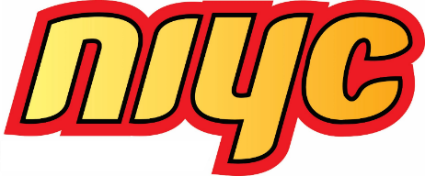
NIYC President

Nomination Form
Nominator Information
First Name: | Last Name:
Date of Birth: (MM-DD-YYYY) | Email:
Please select one of the following:
€ Nunavut Agreement € Labrador Inuit Land Claims Agreement
€ James Bay & Northern Quebec Agreement € Inuvialuit Final Agreement
Enrollment Number:
Nominator Declaration and Signature
I declare that I am an Inuk and between 18 and 35 years of age, that the above information about me is true, and that, to the best of my knowledge, the candidate is an Inuk between 18 and 30 years of age as of the election date.

___________________________________ __________________________
Signature of Nominator Date

Candidate Information
First Name: | Last Name:
Date of Birth: (MM-DD-YYYY) | Email:
Please select one of the following:
€ Nunavut Agreement € Labrador Inuit Land Claims Agreement
€ James Bay & Northern Quebec Agreement € Inuvialuit Final Agreement
Enrollment Number:
Candidate Declaration and Signature
I declare that I am Inuk and between 18 and 30 years of age as of the election date, that the above information about me is true, and that, to the best of my knowledge, the nominator is an Inuk between 18 and 35 years of age.

___________________________________ __________________________
Signature of Application for Candidacy Date

