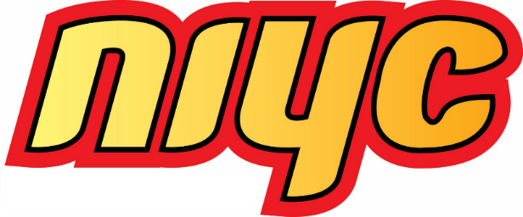
NIYC President
Candidate Application Form

Applicant Checklist
- A cover letter outlining the individual’s skills and experience in a leadership role, their knowledge of issues important to Inuit youth, and a description of what they would like to achieve as NIYC President;
- A completed and signed Candidate Application Form, including 10 signatures of support from fellow Inuit between 18 and 35 years of age;
- Digital photo of passport quality (simple background, no sunglasses or hat), and;
- Current Level 1 Criminal Reference Check (one for each province/territory in which the individual has resided over the past five years

Applicant Instructions
Applicants must be between 18 and 30 years of age as of the election date and must submit the above-mentioned documents to the NIYC Elections Officer no later than 5:00 pm ET on May 23, 2025:
Forms, Rules, and Contact Information
The Candidate Application Form and Nomination Form are available at www.itk.ca/NIYC, on the NIYC Facebook page, or by request from the NIYC Elections Officer. Interested individuals may contact the NIYC Elections Officer with any election related questions.
Deadline for Applications
All documents must be received by the NIYC Elections Officer by May 23, 2025, at 5:00 pm ET. Applicants are responsible for ensuring that applications are properly transmitted and are encouraged to obtain confirmation from the NIYC Elections Officer that their application has been received.

NIYC Elections Officer
Email: NIYC@itk.ca
Phone: 613-238-8181 x208
Mail: 75 Albert Street, Suite 1101, Ottawa, ON, K1P 5E7


NIYC President

Candidate Application Form
Candidate Information
First Name: | Last Name:
Date of Birth: (MM-DD-YYYY) | Email:
Please select one of the following:
€ Nunavut Agreement € Labrador Inuit Land Claims Agreement
€ James Bay & Northern Quebec Agreement € Inuvialuit Final Agreement
Enrollment Number:
Names of Inuit, between 18 and 35 years of age, who support the candidacy (Minimum of 10)
Name (Print)  - ______________________________  - ______________________________  - ______________________________  - ______________________________  - ______________________________  - ______________________________  - ______________________________  - ______________________________  - ______________________________  - ______________________________ | Signature  ______________________  ______________________  ______________________  ______________________  ______________________  ______________________  ______________________  ______________________  ______________________  ______________________ | Email  ______________________  ______________________  ______________________  ______________________  ______________________  ______________________  ______________________  ______________________  ______________________  ______________________
Declaration and Signature
I declare that I am Inuk and between 18 and 30 years of age as of the election date, that the above information about me is true, and that, to the best of my knowledge, the supporting signatures are from Inuit who are between 18 and 35 years of age.

___________________________________ __________________________
Signature of Application for Candidacy Date

